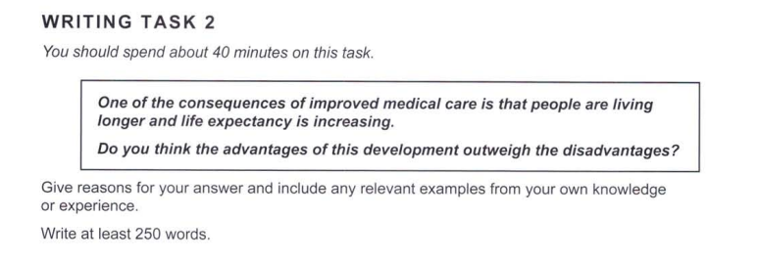

(note: I interpreted it as birth rate when writing. Not sure why.)

The major strides made in medicine have been cited as being the cause of the ‘boom’ in the world population around the 1960s. This rapid growth has continued through the 21st century, and has been predicted to plateau by the next century. But the question that naturally arises is: Is population growth a good thing for humanity?

Firstly, let us consider an advantage: Increasing life expectancies are a signal of better living conditions. When a community gets better access to healthcare, their health no longer impedes their other dreams and ambitions. Such groups are more likely to be able to work harder, bettering their lifestyle, and hence being able to live longer. This would be a positive, a longer lifespan may give people the time they need to figure out their place in the world. The more, the merrier!

However, there is potential for disaster. If the world’s population grows too fast, we run the risk of not having enough resources to meet the needs of everybody sustainably. There is only a finite amount of arable land, and the yield may not satisfy the world’s hunger. Medicines may be a temporary ‘band-aid’ solution to this, but it would be unsustainable in the long-term. This could be disastrous, and may lead to an unmanageable number of deaths, that humans may not be able to get past.

But all is not lost; there is no need to be so nihilistic! As the population rises, people and governments will work to find solutions. There may be campaigns to educate people about the issue, and better education facilities have, so far, been proven to slow down population growth in some countries. Rising life expectancies could coexist with a lower birth rate, and this could help society overall.

In conclusion, the effect of medicine on the population has more advantages than disadvantages, and would be a net benefit for humans.